Task 1

nano hungry.sh
#!/bin/bash
echo “I am hungry. Feed me data.” >> ~/demands.txt
date >> ~/demands.log

My hungry.sh Command Breakdown
Here is how I built the script to handle data demands and logging:
- #!/bin/bash: The shebang that tells my system to use the Bash interpreter to run these commands.
- echo "I am hungry. Feed me data.": This is the output command. It prints the specific text I want to save.
- >>: The Append Redirection symbol. This was the "secret sauce"—it ensures that every time I run the script, it adds a new line to the file instead of deleting the old ones.
- ~/demands.txt: This points to a file in my home directory (~).
- date: A standard command that pulls the current system date and time.
- >> ~/demands.log: This sends that timestamp into a separate log file, appending it to the bottom so I can track every time the script was triggered.
Summary: I created a simple automation that maintains a history of "demands" and a matching log of "timestamps" without ever losing previous data.

Task 2

crontab -e

then,
* * * * * /home/AT-ST/hungry.sh

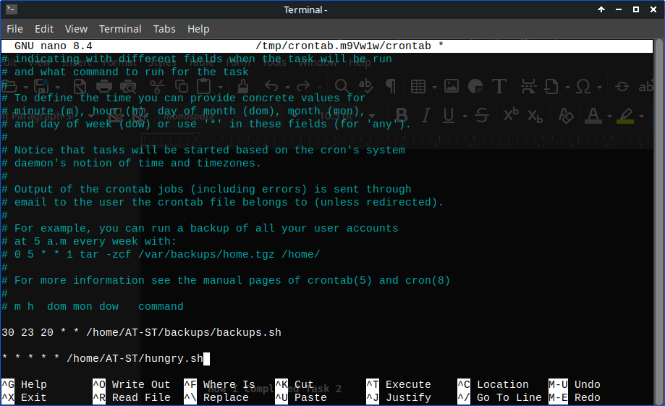

How I Completed Task 2
To satisfy my computer's hunger for data, I set up a recurring schedule using the system’s built-in automation tool. Here is the breakdown:
- crontab -e: I used this command to open my personal cron table (the schedule list). The -e flag stands for edit, allowing me to add new automated tasks.
- The Five Stars (* * * * *): This is the cron timing syntax for "Every Minute."
  - Since every column (minute, hour, day of month, month, day of week) is a wildcard (*), the task triggers at the start of every single minute, 24/7.
- /home/YOUR_USERNAME/hungry.sh: I provided the Absolute Path to the script.
  - Why? Unlike a human, Cron doesn't know what folder it is currently in. By giving the full address starting from the root (/), I ensured the system can find and run my script regardless of its "location."
- Execution: By saving the file, I "installed" the new crontab. Now, my demands.txt and demands.log files will grow every 60 seconds as the script appends new data automatically.
Summary: I successfully linked a custom script to a system daemon to achieve 100% automated logging.

